**2. Fundamental assumptions**The basic assumptions of the constitutive and computational modeling, as well as related limitations, are summarized as follows:

1. Only the configuration of deep tunnels shall be considered in the subsequent analysis, thus neglecting deformations caused by surface loads and settlements arising from the excavation process.
2. Although material heterogeneity and behavior anisotropy are inherent features of soils and rocks, the rock mass is modeled throughout the paper as a homogeneous and isotropic continuous medium. At the scale adopted for tunnel modeling (macroscopic scale), this assumption means in particular that the possible micro-heterogeneities, such isotropic distributions of joints or cracks present at the finer scale, are accounted for in the homogenized behavior by means of a preliminary homogenization process (e.g., [20, 14, 7, 19, 1]). Clearly enough, the framework of continuum modeling adopted in the paper would reveal questionable when the rock mass is cut by a few macroscale fracture joints.
3. The rock mass is phenomenologically modeled using an elastoplastic-viscoplastic rheological law to capture instantaneous and long-term responses. This approach disregards the aspect connected temperature gradients, water flow, and poromechanics coupling.
4. Despite the complexity of the stress distribution prevailing in the rock mass before the process of tunnel excavation, which is mainly affected by the geological history, the present study assumes a geostatic initial stress reflected by vertical and horizontal stresses.
5. Twin tunnels are often designed considering a time gap between excavation fronts. However, the finite element simulations assume synchronous excavation steps to ensure symmetry conditions.
6. The simulation excavation processes are curried out assuming a constant tunnel advancement rate (i.e., constant excavation speed), together with a constant thickness of concrete lining.
7. Effects of temperature and humidity that may affect the viscoelastic behavior of lining concrete are disregarded.
8. Perfect bonding is assumed at the interface between concrete lining and the rock mass.
9. The framework of infinitesimal strain analysis, together with quasi-static evolutions, is adopted in the paper. In particular, dynamic excitations and related inertial forces, such as those induced, for instance, by earthquakes or explosions, shall not be considered in the numerical analysis.

**3. Constitutive Model of the Rock Material**Time-dependent phenomena associated with the delayed behavior of the constitutive material are key aspects of deformation in tunnel structures excavated in deep clayey rocks (see for instance [29, 21] or [16], to cite a few). In most computational analyses developed for tunnel engineering design, this issue is generally addressed by means of viscoplastic constitutive behavior. While such constitutive models could relevantly model the transient and long-term deformation, they seem however inadequate to capture the influence of short-term events (tunnelling and support placement phases) on the final stability of the structure. In particular, an analysis of tunnel deformation based on a viscoplastic model would suggest that the ultimate support pressure at tunnel structure equilibrium mainly depends on the closure rate at the moment when the contact between lining and rock mass is achieved (e. g., [21]), thus disregarding the irreversible effects rising in the initial construction phases. Indeed, during the primary stages of tunnel excavation, the surrounding rock mass is subjected to severe loading conditions and high strain rates, which may lead to yielding associated with high instantaneous irreversible strains near the tunnel wall, and can therefore affect the long-term equilibrium of the structure. It is thus of fundamental concern to formulate a constitutive model that incorporates both instantaneous and delayed irreversible components of the rock material. For this purpose, the present analysis considers a constitutive model that includes both instantaneous plasticity to describe shorth-term material yielding and viscoplasticity to represent delayed behavior. The formulation of the coupled plasticity-viscoplasticity rheological model is based on that originally proposed in [21] and [29]. Previous studies have implemented this plastic-viscoplastic model for computational analysis of deformation in single tunnels (e.g., [6, 23, 16, 25]. For the sake of brevity, only the main features of this constitutive model shall be summarized below. Detailed description of the model, including application and validation in the context of single tunnel structures may be found in [27]. Finite element implementation of this model in the USERMAT procedure of ANSYS software is also described in [25].

The elastoplastic-viscoplastic model is formulated based on a serial association of the elastoplastic and viscoplastic constitutive models. The local strain rate ***𝜺̇*** is split into three contributions ***𝜺̇*** = ***𝜺̇*** *𝑒* + ***𝜺̇*** *𝑝* + ***𝜺̇*** *𝑣𝑝*, so that the constitutive relationships relating the Cauchy stress rate ***𝝈̇*** and strain rate components can be written as:

***𝝈̇*** = ***𝑫*** ∶ ***𝜺̇*** *𝑒* = ***𝑫*** ∶ (***𝜺̇*** − ***𝜺̇*** *𝑝* − ***𝜺̇*** *𝑣𝑝*)*.* (1)

In the above relationship, ***𝜺̇*** *𝑒*, ***𝜺̇*** *𝑝* and ***𝜺̇*** *𝑣𝑝*, represent respectively the elastic, plastic and viscoplastic strain rate, and ***𝑫***

denotes the fourth-order isotropic elastic linear constitutive tensor. Tensor ***𝑫*** is defined by the rock mass elastic Young modulus and Poisson ratio . The one-dimensional representation of the constitutive behavior is shown in Fig. 1. In this model is used a Drucker-Prager plastic flow surface given by

Figure 1: Rheological representation of the elastoplastic-viscoplastic model.

√ (2)

*𝑓* (***𝝈****, 𝑞*) = *𝑓* (*𝐼*1*, 𝐽*2*, 𝑞*) = *𝛽*1*𝐼*1 + *𝛽*2 *𝐽*2 − *𝑞*(*𝛼*)*,* which *𝐼*1 is the first invariant of the stress tensor, *𝐽*2 the second invariant of the deviator tensor and *𝛽*1*, 𝛽*2 and *𝑞*(*𝛼*) are strength parameters related to the friction angle *𝜙* and cohesion *𝑐*(*𝛼*), respectively. In the present model Drucker-Prager surface been inner of the Mohr-Coulomb surface [5], that is,

*𝛽*1 = 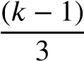 *, 𝛽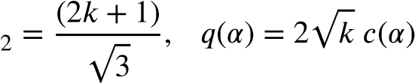,* (3)

where *𝑘* = (1 + sin *𝜙*)∕(1 − sin *𝜙*). The internal variable *𝛼* is the equivalent plastic strain *𝜀̄𝑝* used to simulate strain hardening/softening phenomena. However, for this study, we adopt perfect plasticity, meaning that c is a constant. For the viscoplasticity surface *𝑣𝑝* the same surface is empolyed, but with *𝑣𝑝* in and , and *𝑣𝑝* √ *𝑣𝑝* where

*𝑓 𝜙 𝛽*1 *𝛽*2 *𝑞* = 2 *𝑘* − *𝑐𝑣𝑝*

*𝑘𝑣𝑝* = (1 + sin *𝜙𝑣𝑝*)∕(1 − sin *𝜙𝑣𝑝*) and *𝑐𝑣𝑝* is a constant, i.e., perfect viscoplasticity. The plastic flow rule is given by:

# { 𝜕𝑔

*̇𝑝* = *𝜆̇ 𝜕****𝝈*** forfor *𝑓* ≤*>* 0 *,* (4)

## *𝜺*

### **𝟎**, 𝑓 0

where *𝜆̇* is the plasticity multiplier and *𝑔* is a potential flow function analogous to *𝑓* used to simulate the volume dilatation during the evolution of plastic deformations. However, for this analysis, was used associated plasticity, i.e., *𝑔* = *𝑓* . The plastic multiplier is obtained through the consistency condition *𝑓̇* = 0. Numerical details of this implementation can be found in [27]. For viscoplastic flow rule we have,

*𝑣𝑝 𝜕𝑓 𝑣𝑝*

***𝜺̇*** = *𝜆̇ 𝑣𝑝*  (5)

## *𝜕𝝈*

In contrast to the plastic multiplier, the viscoplastic multiplier *𝜆𝑣𝑝* is independent of a consistency like condition. As a result, its expression is explicit. Based on the framework of generalized Perzyna’s overstress theory [22], its expression may be derived as follows:

*𝑣𝑝* Φ(***𝝈****, 𝑞𝑣𝑝*) and Φ = ⟨ *𝑓 𝑣𝑝*(*𝑓****𝝈***0*, 𝑞𝑣𝑝*)⟩*𝑛 ,* (6)

### 𝜆̇ =

*𝜂* where Φ is the overstress function, *𝜂* is the dynamic viscosity constant, *𝑛* is the dimensionless parameter that gives the form of the power law, *𝑓*0 a parameter conveniently adopted and ⟨∗⟩ is the McCauley function which is 0 when ∗*<* 0 , i.e. viscoplastic flow will only occur when the overstress function is positive.

In this coupled model, when *𝜙* = *𝜙𝑣𝑝*, cohesion entirely controls the evolution of local mechanical fields. Specifically, when *𝑐* → ∞ and *𝑐𝑣𝑝* → ∞, the system achieves a purely elastic solution. The solution becomes purely elastoviscoplastic with *𝑐* → ∞, while a pure elastoplastic solution emerges with *𝑐𝑣𝑝* → ∞. In the coupled analysis, condition *𝑐𝑣𝑝 < 𝑐* is adopted, allowing the viscoplastic domain to occur without plasticity. However, in the presence of plasticity, viscous effects become inevitable. Fig. 2 illustrates these domains in principal stress space.

Elastic domain

Elastic-viscoplastic domain Elastic-plastic-viscoplastic domain

Viscoplastic surface

Plastic surface



Figure 2: Elastoplastic-viscoplastic domains.

## 4. Constitutive Model of the Lining

Shrinkage and creep phenomena represent fundamental components of concrete deformation processes that are expected to naturally affect the instantaneous as well as the transient and long-term behavior of structures involving such material. However, most of the tunnel design analyses consider the concrete involved in lining systems as a linear elastic material. From a phenomenological point of view, creep of concrete refers to the time-dependent deformation induced by sustained loading, whereas shrinkage deformation refers to the volume decrease caused by drying. As far as deformation in tunnel structures is concerned, creep and shrinkage have an important effect on the performance of the concrete lining and consequently on its contribution to controlling the long-term convergence of the tunnel. To account for such constitutive features, the concrete creep deformation is addressed by means of an aging viscoelastic rheological model relying on Bažant and Prasannan Solidification Theory [3, 4]. The viscoelastic model is described by Generalized Kelvin chainl as depicted in Fig. 3. The mechanical parameters that define such a rheological model are the springs stiffness and dash-pots viscosity. These model parameters are calibrated based on the CEB-FIP MC90 standard specifications formulation reported in [8]. One may refer to [26, 28] for detailed description of the calibration procedure. As regards the concrete deformation associated with shrinkage, the isotropic formulation proposed in CEB-FIP MC90 standard [8] is adopted in the present modeling and subsequent computational analyses. Full details regarding model definition and related finite element implementation may be found in [24] and [26].

Accordingly, the constitutive equations for concrete lining relating the stress and strain rate can be expressed in the

framework of infinitesimal strain analysis as:

***𝝈̇*** = ***𝑫*** ∶ ***𝜺̇*** *𝑒* = ***𝑫*** ∶ ***𝜺̇*** − ***𝑫*** ∶ ***𝜺̇*** *𝑠ℎ* − ***𝑫*∗** ∶ ***𝜺̇*** *𝑐𝑟* (7)

Figure 3: Generalized Kelvin model for uniaxial concrete viscoelasticity.

In the above relationship, ***𝜺̇*** *𝑠ℎ* and ***𝜺̇*** *𝑐𝑟* are respectively the shrinkage and creep strain rates. The fourth-order tensors ***𝑫*** and ***𝑫*∗** refer to the isotropic elastic linear constitutive tensor and modified constitutive tensor that incorporate the aging viscoelastic properties of the concrete, respectively.

For the numerical implementation purposes, relationship (7) may conveniently be written in incremental form:

Δ***𝝈*** = ***𝑫*** ∶ Δ***𝜺*** − ***𝑫*** ∶ Δ***𝜺****𝑠ℎ* − ***𝑫*∗** ∶ Δ***𝜺****𝑐𝑟* (8)

As mentioned above, isotropic formulation is considered for shrinkage, so that increment of shrinkage strain reads:

Δ***𝜺****𝑠ℎ* = Δ*𝜀𝑠ℎ*(*𝑡𝑠*)**𝟏** (9) where *𝑡𝑠* represents the concrete curing time, and Δ*𝜀𝑠ℎ* is the variation in magnitude of the concrete deformation associated with shrinkage (the dependency Δ*𝜀𝑠ℎ* of on current time is omitted). The latter expression is determined based on CEB-FIP MC90 standard specifications [8].

Regarding the increment of creep strain Δ***𝜺****𝑐𝑟* , its value is computed making use of the incremental algorithm developed by Bažant and Prasannan [3; 4], together with a model calibration that incorporates CEB-FIP MC90 standard formulation [8]. More precisely, the three-dimensional ageing viscoelastic behavior of isotropic concrete is defined by the Generalized kelvin model for the relaxation modulus under uniaxial stress, whereas the Poisson ratio is assumed to be time independent within the time interval of analysis. The procedure for the identification of model parameters is achieved by comparing the creep functions provided in references [3,4] and [8], leading to the following equivalence:

0 *𝑐* 0 0 *𝑐* 0 1 *𝜙*0 and 1 (10)

*𝐸* = *𝐸* (*𝑡* )*, 𝛾* (*𝑡* − *𝑡* ) = *𝛽* (*𝑡* − *𝑡* )*,* = → 0

*𝑣*(*𝑡*) *𝐸𝑐𝑖 𝜂*(*𝑡*)

in which *𝑡* refers to the current time value and *𝑡*0 to the concrete age at the instant of load application (time interval *𝑡* − *𝑡*0 is generally referred to as loading time or loading age). In the Generalized kelvin model introduced by Bažant and Prasannan [3; 4], *𝐸*0 is the instantaneous elasticity modulus of the concrete formed aggregates and cement paste particles, *𝛾* (*𝑡* − *𝑡*0) is the microviscoelastic deformation of the volume fraction *𝑣*(*𝑡*) of solidified concrete and *𝜂*(*𝑡*) is the apparent macroscopic viscosity. In the CEB-FIP MC90 formulation [8], *𝐸𝑐*(*𝑡*0) stands for the tangent elastic modulus of concrete at the instant of the loading application *𝑡*0, *𝛽𝑐*(*𝑡* − *𝑡*0) is a coefficient that depends on the loading age *𝑡* − *𝑡*0, *𝜙*0(*𝑡*0) is a coefficient defining the delayed strain when loaded at age *𝑡*0 of the concrete, and *𝐸𝑐𝑖* represents the tangent elasticity modulus of the concrete at the age of 28 day.

## 5. Spatial and time discretization of the domain

The geometry model of analyzed domain Ω is schematically displayed in Fig.4. It consists of a system of deep twin tunnels connected with a transverse gallery. The radius of the circular longitudinal tunnels is denoted by , whereas that of the circular connecting gallery is denoted by . The underground structure is excavated in a homogeneous rock mass at great depth . Within the analyzed material domain, the initial stress state prevailing in the rock mass prior to the tunnel excavation process is defined by constant vertical and horizontal geostatic stress  and , taking the following form:

Figure 4: Schematic representation of the twin tunnels geometry problem.

 (XX)

where is the upward unit vector parallel to vertical direction. The initial horizontal stress is generally related to the vertical stress by means of the horizontal thrust coefficient . Starting from the initial configuration of the material system Ω, the processes of excavation (advancing face) and lining placement are simulated by means of the “activation/deactivation” technique [Bernaud et al. (1995), Bernaud et al. (2009), Maghous et al. (2012), Quevedo et al. (2022)}.

The geometry material domain Ω considered for the finite element simulations, including tunnelling and deformation analysis, is defined by a parallelepiped volume of dimensions  (Fig. 5). Owing to the symmetry of the problem, only the material portion  is considered for F.E discretization and analysis. Referring to the notations of Fig. 4, *𝑑*1 is the distance between the axes of longitudinal tunnels, *𝐿*2 represents the total length along longitudinal direction  of the cylindrical volume to be excavated that is considered in the numerical simulation, *𝑑*3 is the thickness along vertical direction  of material domain Ω, *𝐿*1 stands for the length of unexcavated region after total excavation process, *𝐿*3 is the total length along transversal directionof discretized material domain, *𝑑*2  characterizes the location of the circular transverse axis gallery that intersects the longitudinal tunnel at . The length of the excavation step adopted will be denoted by *𝐿𝑝*. The finite element model including geometrical discretization and boundary conditions is illustrated in Fig. 5. The mesh used in the simulations consists of 119740, 182470 or 221104 total elements (hexahedra and tetrahedra), depending on the value of spacing between longitudinal tunnels. To increase the accuracy of the model predictions in the intersection zone, the region surrounding the transverse gallery (including part of the longitudinal tunnel) is discretized by means 10-node quadratic tetrahedral elements, whereas 8-node trilinear hexahedral elements are used for the remaining part of the structure. Furthermore, a refined meshing is used for discretizing the zones surrounding the longitudinal and transverse gallery. These zones whose mechanical state is significantly affected by the tunnelling process are indicated by gray color in Fig. 5

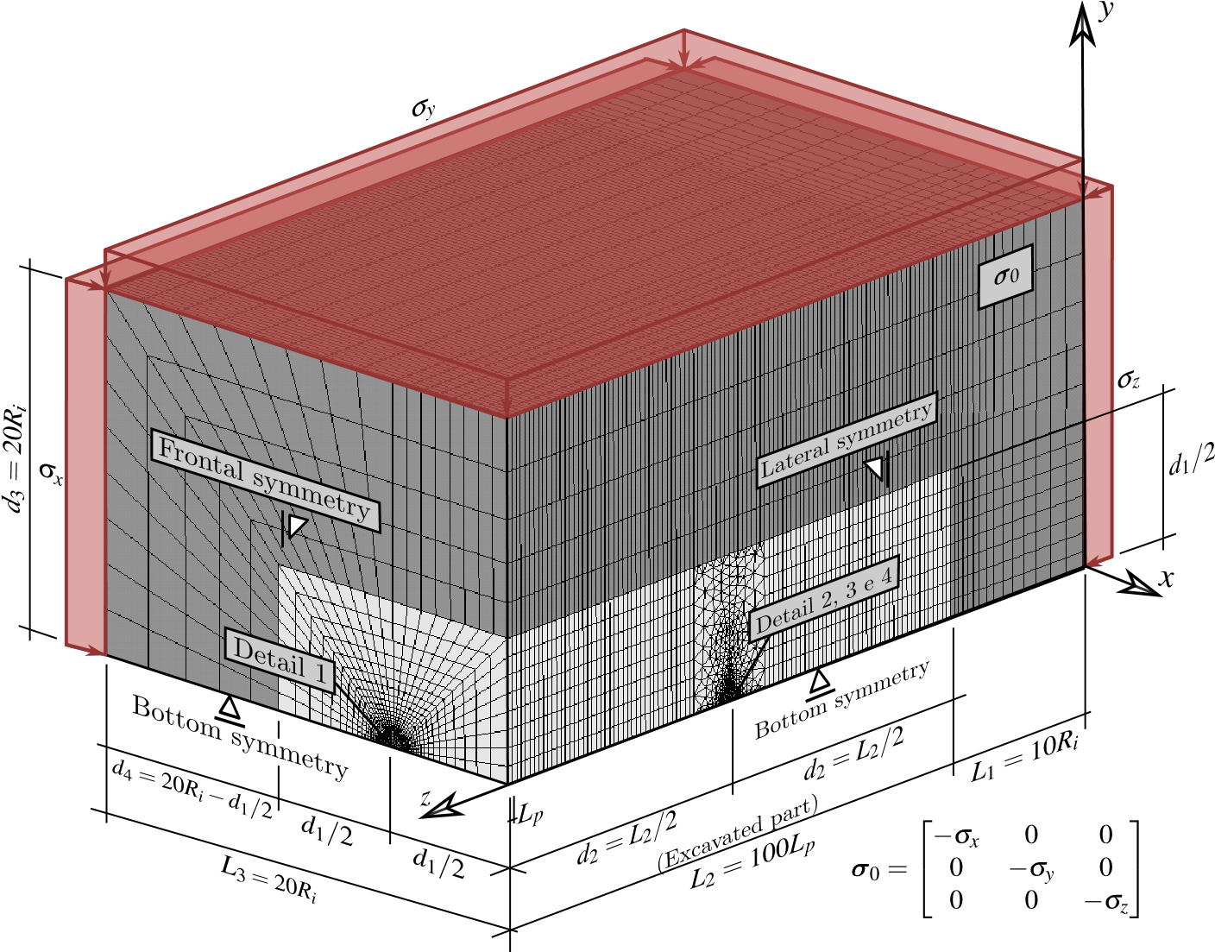

Figure 5: Finite element model used in the numerical simulations: domain geometry, F.E mesh and boundary conditions.

Figures 6 to 10 display some details regarding the geometry and F.E discretization of the structure. Fig. 6 presents some details of the longitudinal tunnel cross-section in a  plane, together with the layer of concrete lining (in sky blue color), parameter ** being the thickness of the lining. Installation of the lining (shotcrete or precast concrete) is simulated in the F.E modeling by progressive activation of the corresponding elements, which consists in assigning to these elements the concrete mechanical properties.

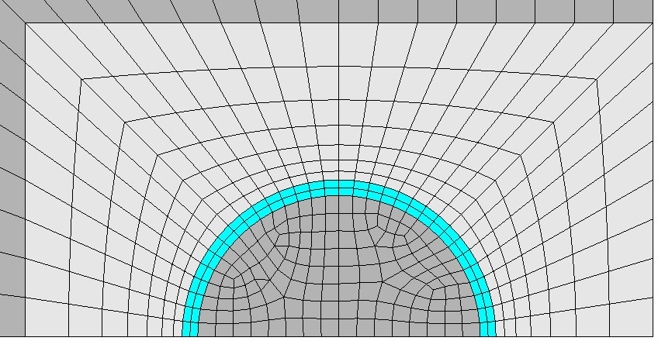

*d*

*1*

2

*x*

*y*

Figure 6: Geometry and F.E mesh of longitudinal tunnel cross-section with spacing *𝑑*1 =4*𝑅𝑖*.

An important issue investigated in this work is the influence of the spacing *𝑑*1  between twin tunnels on their convergence. Fig. 7 and Fig. 8 illustrate the spatial discretization of the gallery region as well as of the connection with the longitudinal tunnel. Three values shall be considered for the spacing *𝑑*1  in the numerical simulations, namely *𝑑*1 = 16*𝑅𝑖,* 8*𝑅𝑖* and 4*𝑅𝑖*, . The layer of concrete lining of thickness ** installed along the gallery wall is indicated by red color in the figures. Without introducing additional modeling restriction and for the sake of simplicity, the value of the gallery radius is fixed to . The same lining system (same concrete material and layer thickness) is considered for both longitudinal tunnels and gallery. As regards the discretization of the region surrounding the gallery, parameters *𝑑*5 and *𝑑*1 define the size in a  plane of the transition region involving the tetrahedral finite elements. Fig. 9 provides a view of the transition region and tunnel/gallery intersection zone.

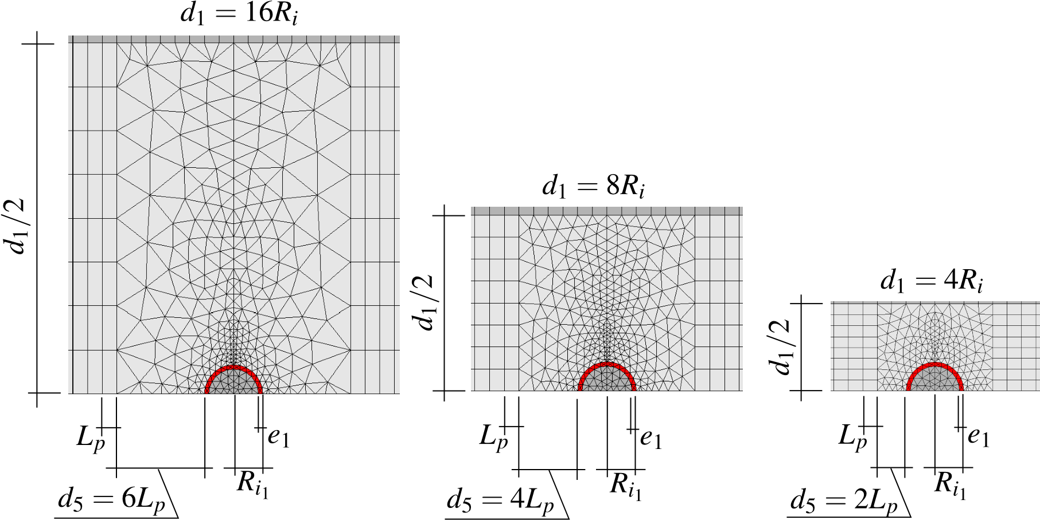

Figure 7: Geometry and F.E mesh of gallery cross-section for configurations *𝑑*1 =16*𝑅𝑖*, *𝑑*1 =8*𝑅𝑖* and *𝑑*1 =4*𝑅𝑖*.

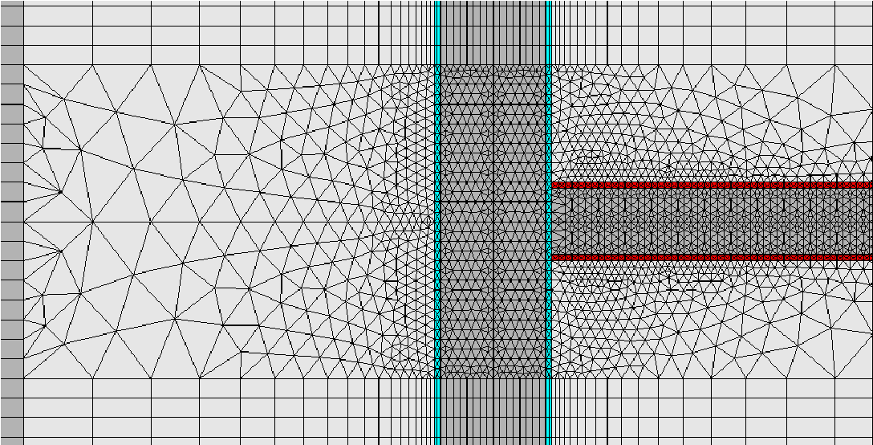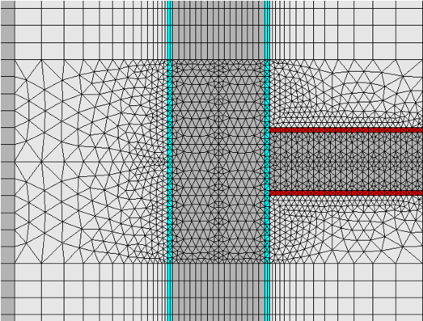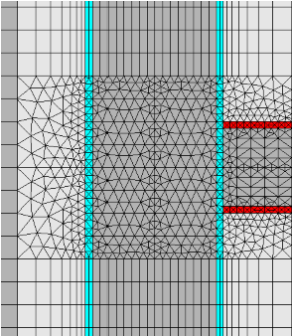

Figure 8: Views of longitudinal tunnel and gallery in the symmetry plane for configurations *𝑑*1 =16*𝑅𝑖*, *𝑑*1 =8*𝑅𝑖* and *𝑑*1 =4*𝑅𝑖*.

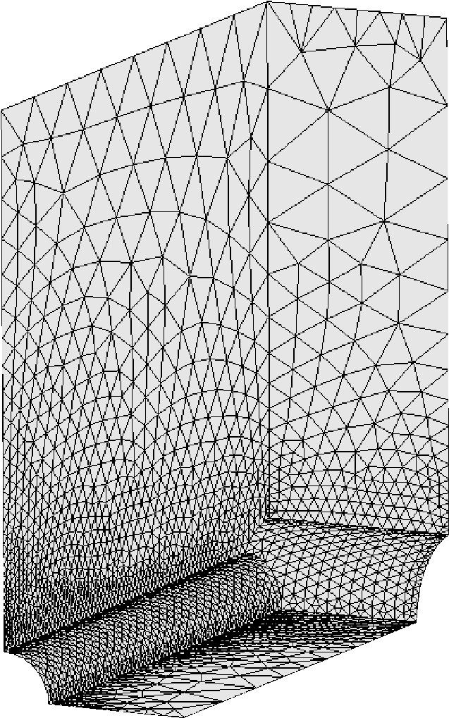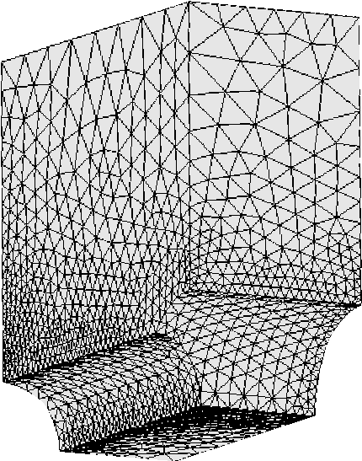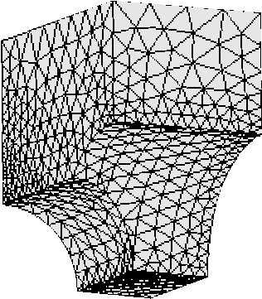

Figure 9: View of the transition and tunnel/gallery intersection zones for configurations *𝑑*1 =16*𝑅𝑖*, *𝑑*1 =8*𝑅𝑖* and *𝑑*1 =4*𝑅𝑖*.

Finally, Fig. 10 presents the F.E mesh used for the layer of concrete lining in both the longitudinal layer (in sky blue color) and the gallery (in red color) for the three configurations *𝑑*1 = 4*𝑅𝑖,* 8*𝑅𝑖,* and 16*𝑅𝑖* , with specific details on the junction region of the gallery and the longitudinal tunnel for *𝑑*1 = 4*𝑅𝑖,* 8*𝑅𝑖,* and 16*𝑅𝑖*. For the illustration purposes, symmetry with respect to plane has been used to complete the geometry representation of each configuration. It is emphasized that the tetrahedral elements used for the discretization of the region surrounding the transverse gallery exactly fits excavation steps (elements removal or deactivation).

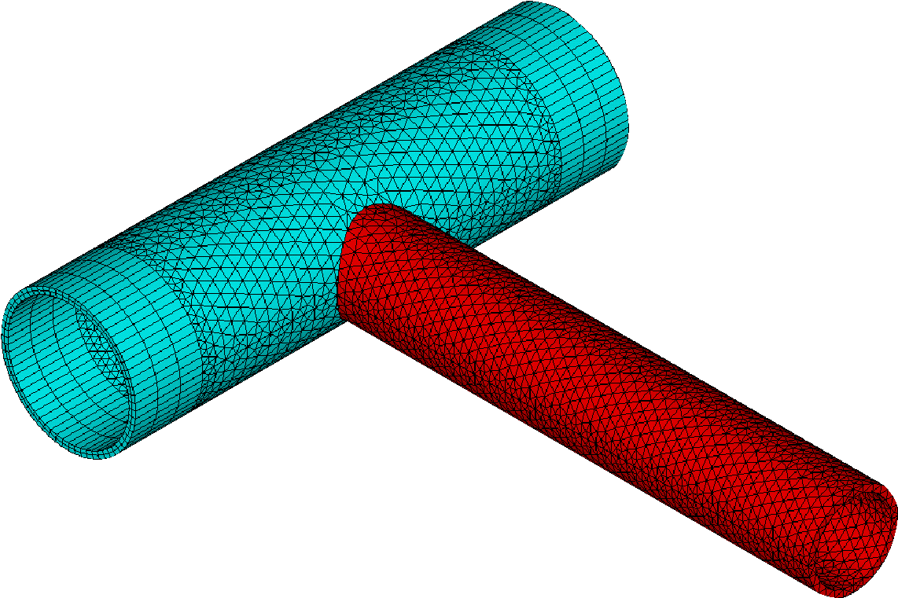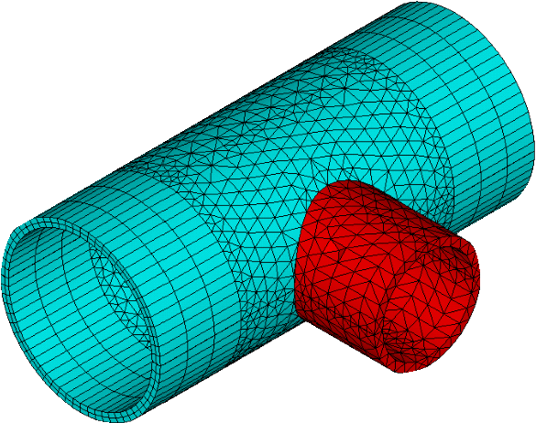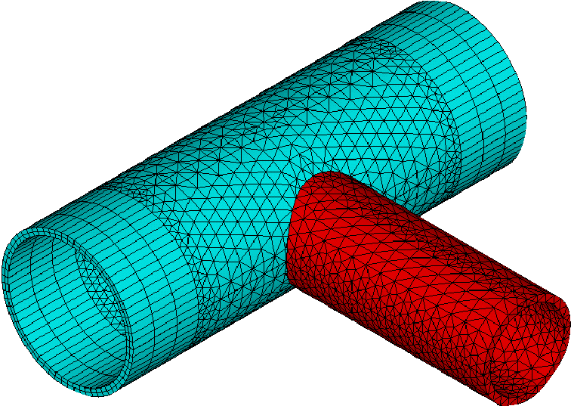

Figure 10: View of the discretized lining layer at the gallery/longitudinal tunnel junction for intersection for configurations *𝑑*1 =16*𝑅𝑖*, *𝑑*1 =8*𝑅𝑖* and *𝑑*1 =4*𝑅𝑖* (symmetry with respect to planehas been used).

As mentioned previously, the tunnelling process, including the excavation steps and lining installation, is simulated resorting to the activation-deactivation method. Each excavation step is modeled by deactivation of the corresponding elements (the elements stiffness is reduced by a factor 1E8), whereas installation of elements of lining at a distance *𝑑*0 from the excavation face (unlined length) is achieved through activation of the corresponding elements by assigning them concrete properties. The F.E solution of the time-dependent problem is performed for each excavation step associated with time interval *𝑡𝑝* = *𝐿𝑝*∕*𝑉𝑝*, where *𝐿𝑝* represents the length of the excavation step and *𝑉𝑝*  is the speed of the excavation face. Fig. 11 schematically displays the consecutive phases of excavation process. In this Figure, *𝑛𝑝* is the total number of excavation steps and  *𝑛𝑝𝑖𝑔* represents the number of longitudinal tunnel excavation steps prior to gallery excavation. After achievement of the *𝑛𝑝𝑖𝑔* excavation steps, the excavation of the gallery is initiated starting from the longitudinal tunnel wall. Referring to the notation of Fig. 11, *𝐿𝑝*1 is the considered step length for the gallery excavation, *𝑉𝑝*1 is the speed of the gallery excavation, and *𝑑*01 is the unlined length of the gallery. Each gallery excavation step is associated with time interval *t𝑝*1 =*𝑉𝑝*1  / *𝐿𝑝*1 . After the gallery excavation is completed, we proceed to further excavation steps of the longitudinal tunnel.

For the sake of clearness, the main parameters defining the geometry domain as well as and excavation process and lining installation are summarized in Table 1.

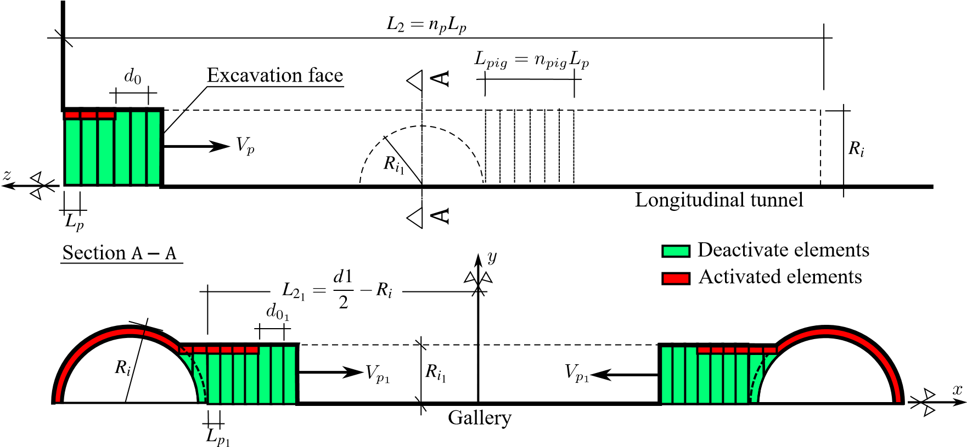

Figure 11: Schematic representation of the excavation process.

Table 1. Main parameters defining domain geometry of the domain, excavation process and lining installation.

|  |  |  |  |  |  |  |
| --- | --- | --- | --- | --- | --- | --- |
| PARAMETERS SYMBOL | | | UNIT |  | VALUES | |
| Longitudinal tunnels | | |  |  |  | |
| Radius of the longitudinal tunnel | *𝑅𝑖* | | m |  | *𝑅𝑖* | |
| Thickness of the lining | *𝑒* | | m |  | 0*.*1*𝑅𝑖* | |
| Step length of the excavation process | *𝐿𝑝* | | m |  | 1∕3*𝑅𝑖* | |
| Unlined length | *𝑑*0 | | m |  | 2*𝐿𝑝* | |
| Speed of the excavation face | *𝑉𝑝* | | m/day |  | 12.5 | |
| Excavation step time | *𝑡𝑝* | | day |  | *𝐿𝑝*∕*𝑉𝑝* | |
|  | Gallery | |  |  |  | |
| Radius of the gallery | *𝑅𝑖*1 | | m |  | 2∕3*𝑅𝑖* | |
| Thickness of the concrete lining | *𝑒*1 | | m |  | 0*.*1*𝑅𝑖* | |
| Step length of the excavation process 1 | *𝐿𝑝*1 | | m |  | 1∕3*𝑅g* | |
| Unlined length | *𝑑*01 | | m |  | | 2*𝐿𝑝*1 |
| Speed of the excavation face | *𝑉𝑝*1 | | m/day |  | | 12.5 |
| Number of steps that starts gallery excavation | | *𝑛𝑝𝑖𝑔* | un |  | | 15 |
| Rest of domain | | |  |  | |  |
| Distance between longitudinal tunnel axes | | *𝑑*1 | m | 4*𝑅𝑖* | | 8*𝑅𝑖* 16*𝑅𝑖* |
| Length of the unexcavated region | | *𝐿*1 | m |  | | 10*𝑅𝑖* |
| Total excavated length | | *𝐿*2 | m | 100*𝐿𝑝* | | |
| Domain height | | *𝐿*3 | m | 20*𝑅𝑖* | | |

1

Valuer of *𝐿𝑝*1 is slightly different for the last excavation step to match the gallery length.

During the tunnel construction phases, the time increment used for the time-dependent analysis is automatically managed by the ANSYS solver. The latter makes use of a semi-implicit scheme for the viscoplasticity solution, together with an automatic time stepping algorithm [\citenum{zienkiewicz1974visco}] in which the time step is defined as a fraction of time *t𝑝* for the phases of longitudinal tunnel excavation and as a fraction of *t𝑝*1 for the phases of transverse gallery excavation. Furthermore, distinct time steps are considered for the time-dependent analysis during tunnelling process and post-excavation stage. After complete tunnel construction phases, the analysis is carried out for a period of about 3000 days to assess the time evolving deformation as well as long-term viscous effects on the final equilibrium of the tunnel structure. At that respect and in anticipation of the numerical results of the subsequent sections, the characteristic viscoplastic relaxation time [Simo and Huges 1998, {Simo JC, Hughes TJR, Computational Inelasticity. Springer; 1998}] is equal to , which is close to 30 days for model data of Table 2.